OLD DEE BRIDGE

BRIDGE

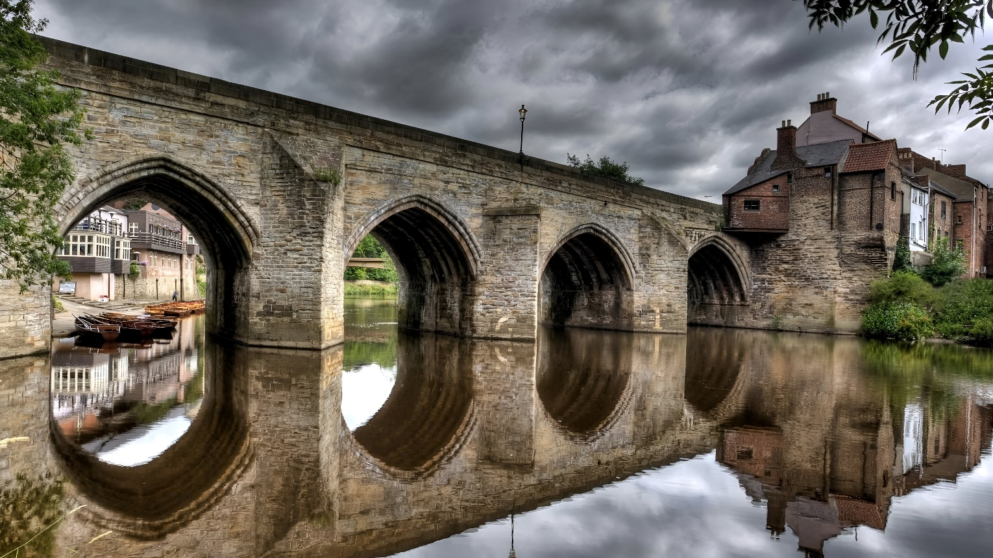

The Old Dee Bridge, a historic gem nestled within the scenic landscape of Chester, England, stands as a testament to the enduring spirit of British ingenuity and craftsmanship. Constructed in the 13th century, this charming stone bridge spans the River Dee, connecting the bustling city center of Chester with the surrounding countryside. With its weathered stone arches, ancient masonry, and iconic cobbled roadway, the bridge exudes rustic charm and nostalgia, evoking a bygone era of medieval grandeur and architectural splendor.

As one traverses the Old Dee Bridge, they are transported back in time to an era when such bridges were vital lifelines for trade, commerce, and travel. The sound of horses' hooves clattering across the cobbled surface, the rhythmic flow of the river below, and the sight of sunlight dappling through the arched openings all combine to create a sense of serenity and timelessness.

Beyond its quaint appearance, the Old Dee Bridge holds significant historical and cultural significance for the local community and the wider region. It stands as a symbol of the resilience and resourcefulness of medieval craftsmen, who built these bridges to withstand the rigors of daily life in a bustling medieval town. Moreover, the bridge serves as a tangible link to the past, connecting generations of residents and visitors alike with the rich history and heritage of Chester.